Member Care Manual
“Supporting the membership journey”

Appendix H
New Member Orientation
Techniques

New Member Activity Check Sheet

Welcome to the Rotary Club of ___________________! Over the course of the next six months (or sooner if you choose!) we would like to get to know you and also help you to get to know our fun dedicated members! Completing this checklist will help us do that. You’ll also learn more about the incredible work that Rotarians do in our local, national and international community.

Use this Activity Check Sheet with the help of your sponsor/mentor as a way to guide your increased engagement in our club. Thank you!

NAME:______________________________________________________

Month/Year of Your Induction into the Club________________/_________

Event/Activity | Date | Sponsor/Mentor Signature
Watch “This is Rotary” video on YouTube
Read “Rotary Basics”
Read “The Rotary Foundation Reference Guide”
Open a DACdb account and complete a profile
Open a MyRotary account and explore the site
Join the Club’s Facebook page
Attend New Member Orientation
Serve as a “Greeter” at a club meeting
Attend a Board meeting
Attend a Committee meeting
Bring a guest to a Rotary meeting
Participate in a club service project
Attend a club social event
Attend a meeting of another club
Give a personal profile or vocational talk at a club meeting
Speak with your Sponsor / Mentor to help you locate any of the above and assist you in completing the activity.

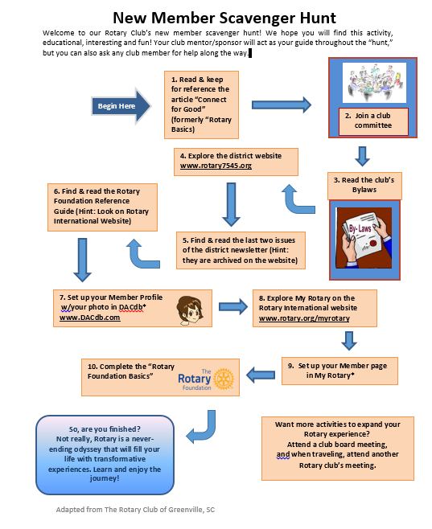

Adapted from a checklist used by the Rotary Club of Reedy River, Greenville SC. This checklist can be adapted to your club. Two ways in which it has been include: - New members are given a temporary badge when joining and receive their permanent badge when the list has been completed - Members completing the list are awarded 250 recognition points toward becoming a Paul Harris Fellow by the club.

